**Brandon Valladolid**

**Engr-1050, Introduction to Nanotechnology, Spring 2016 (MW 7:30 -8:50 am)**

**Professor Cristan Ellison**

**Date: March 30. 2016**

**Subject: e-Portfolio Paper, entitled “Nano Material Reinforced Asphalt”**

**Nano Material Reinforced Asphalt**

**By Brandon Valladolid**

**Introduction**

We all have experienced the effects of an aging asphalt road. The degradation of this type of road not only cost the public in taxes, but our governments in labor, time and materials. The beginning of the semester we learned about Carbon nanotubes and industrial applications. I found the applications of CNTs into road materials very interesting. We punish our asphalt roadways 24 hours a day, 365 days a year. The idea of creating a road material that is far superior to the traditional asphalt, would lessen our need for repaving at such frequency.

In our discussions, we learned that a carbon allotrope like Graphene can be made into a carbon nanotube structure. Which can be either Single wall or Multi-wall. In this discussion we are going to be talking about the use of SWCNT. The reason for using SWCNT is logical since they have a high tensile strength but are flexible. But SWCNT are not the only nano material that is being added to and asphalt emulsion. NanoSilica and Poylmer modified nano clay have also been materials that have been introduced to the asphalt binder. These nano materials added to the binder make a difference in multiple areas. This makes them a perfect addition into our roadway materials.

The Information gathered shows Zhanping You at Michigan Technological University has headed the research. The idea is that the nano materials as pictured beloware used in several different methods to reduce the effects of rutting, creep and degradation of asphalt at high temperatures. I will discuss the three ways this has been applied to asphalt. 

**Fundamental Concepts**

Now that you have an idea of this type of application to our current roads. I will outline three fundamental concepts that in the use of nano materials into asphalt can improve characteristics.

Fundamental Concept 1.

Asphalt binders are transferred multiple times throughout production. Thus, viscosity is important in material handling and mixing of the emulsion at the factory and onsite. Viscosity must have a maintained minimum to be able to lay it down at a proper thickness for peak performance of the material. The addition of nano materials can have a positive effect on the viscosity. Asphalt installation is dependent on temperature. If the temperature is too hot then the asphalt has a higher viscosity and will not lay into the desired thickness and performance of the finished product would be compromised. You and his team have added PMN to asphalt binders at a 2-4% by weight lessened the viscosity. This would give the asphalt a far greater temperature range for installation.

Fundamental Concept 2.

Next is Performance Grade of the asphalt binder. The permanent deformation or “Creep” of asphalt is characterized by rutting. Which is the breakdown of the asphalt due to pressure and weight and use frequency. This actually creates a rut or grove in the road once the asphalt has started to rut it will shear and pothole will begin to form. This is dangerous for all of us that use the roadways.

The addition of the PMN or SWCNT into the binder would have more resistance to the rutting effect on the roadway. Since SWCNT have a high tensile strength we can imagine that the addition of them into a binder material can add strength and resist the downward pressures that are placed on the material during use. During the tests that *You* did he was able to show that adding CNT in the proper dispersion enhanced the strength of the binder He found that the strength of the binder was dependent on the process of dispersion into the binder, Either method of dispersion into the binder increased the shear value of the binder over the non CNT binder.

The addition of PMN to the binder reduces the rutting effect by almost half. There have not be comparative studies on which nano material reduces permanent deformation the most. The PMN dispersion was quite even in a simpler process then the addition of CNT into the binder. This may be a more cost effective way to strength asphalt binders. The image below shows the distribution of PMN in the binder.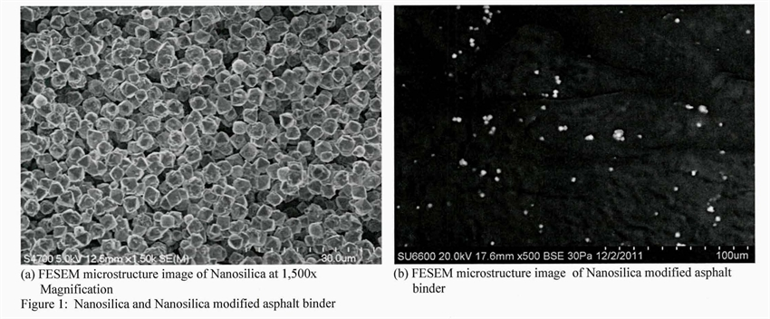

Fundamental Concept 3.

The third fundamental concept is the effect of adding nano material to the asphalt binder has on the ductility of the asphalt binder. Asphalt binders have to resist low temperatures and not crack. In the state we live in the temperatures can get very low. Have you ever wondered what that does to an asphalt roadway? The lower the ductility of the binder the better it will resist the low temperatures. The addition of CNTs to the binder lowered the docility of the binder drastically. The test the *You* did showed different percentages of CNTs added to the binder. Adding 1% CNT to the binder had the best result.

Fundamental Concept 4

Now that we have talked about the low temperatures. The opposite is the resistance to high temperatures or “Creep Recovery”. The binder must endure high temperatures as well and adding nano materials to the binder especially CNTs increased the resistance to the heat. Creep recovery is important. The reasons are for example if you have a heavy load being transferred across the binder surface then Creep will happen if the temperature is high enough. This will also cause rutting of the binder. The binder must recovery its shape after the load has passed. The addition of CNTs in abundance would entangle them and the entanglement would resist the outward force and return to its original shape.

**Current Investigations**

The investigation of Nano technology used in this paper varies from 2011 to 2015. The research done at the Michigan Technological University has drawn a lot of attention from multinational companies that are wanting to reduce the frequency of having to repave roads. The high cost of petroleum has helped these ideas gain traction. The benefits of using nano materials in asphalt emulsions are huge. In the United States alone we have to do costly repairs due to the effects of the cold and heat based on seasons. We annually have road crews out filling in the rutting of the roads. The cost of these repairs are paid by taxes. This idea would reduce those costs and help our country use some of that funding elsewhere. The industrial application of this type of material would reduce the need for petroleum and let us use those resources in other commercial areas.

**References**

Ragab, M., Abdelrahman, M., & Ghavibazoo, A. (2015). Effect of Interaction Parameters on the Hardness and Elastic Modulus of Crumb Rubber Modified Asphalt. *International Journal Of Pavement Research & Technology*, *8*(3), 199-205. doi:10.6135/ijprt.org.tw/2015.8(3).199

Yao, Hui, et al. "Rheological Properties And Chemical Bonding Of Asphalt Modified With Nanosilica." *Journal Of Materials In Civil Engineering* 25.11 (2013): 1619-1630. *Academic Search Premier*. Web. 1 Apr. 2016.

Zhanping, You. "Nanomaterials In Asphalt Pavements." *International Journal Of Pavement Research & Technology* 6.3 (2013): IV-V. *Academic Search Premier*. Web. 1 Apr. 2016.

Amirkhanian, Armen N., Feipeng Xiao, and Serji N. Amirkhanian. "Characterization Of Unaged Asphalt Binder Modified With Carbon Nano Particles." *International Journal Of Pavement Research & Technology* 4.5 (2011): 281-286. *Academic Search Premier*. Web. 1 Apr. 2016.

Xiao, Feipeng, Armen N. Amirkhanian, and Serji N. Amirkhanian. "Long-Term Ageing Influence On Rheological Characteristics Of Asphalt Binders Containing Carbon Nanoparticles." *International Journal Of Pavement Engineering* 12.6 (2011): 533-541. *Academic Search Premier*. Web. 1 Apr. 2016.

**Nano Material Reinforced Asphalt**

**By BrandonValladolid**