Brandon Valladolid
Professsor Brown
Music 1040
July 31, 2017
A Jam Session
We attended a jam session that was hosted at the Green Pig in Salt Lake City, Utah. In this discussion, we will go over elements that together made up the jam session. The subcultures that were apparent at the event and talk about a few of the musicians that were present and participated at the session.
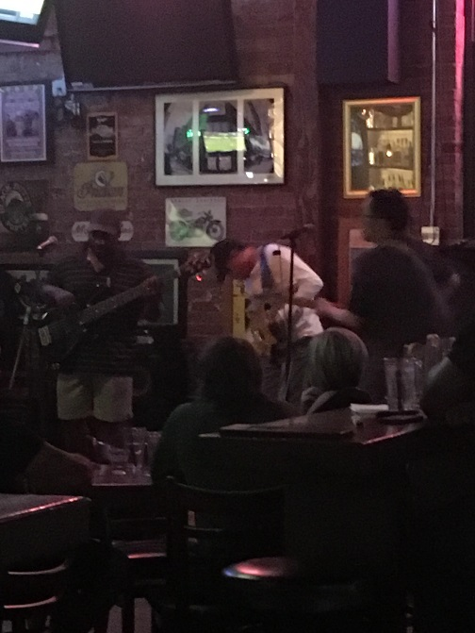
First let’s talk about subcultures and how they came together and were a working part of the event. Upon arriving at the event, the First thing that was noticed was the bar subculture. The performers had not quite setup yet and the crowd was enjoying each other’s company while waiting for them. The initial thought was that the session could be any type of music the crowd was in no way dressed to fit a certain subculture. Their subculture was simply the bar scene. As each perform arrived at the bar there was a sense of their musician quality in the way their carried themselves to the stage checking with the host Gary. The musicians were obviously a part of their own subculture. Each of them had their own look but staying within their own subculture of Blues. One musician was dressed in a slim pair of pants, dark sweater and adoring a thin gold chain. After the session started quickly a subculture that was blending in at the bar arose to the dance floor in the form of swing dancers. They were not dressed in a manner other that for a bar scene. As they danced it was immediately notice by the rest of the bar scene that these folks were apart of another subculture. They were immediately accepted in the Blues scene. As their dance moves were initially to energetic for the Blues scene they quickly molded to fit the genre of blues. They didn’t quit dancing the entire session. The other obvious subculture that was present was the students that were there to observe and review the event. That subculture in the beginning stuck out like a sore thumb. But as the music began to flow the students started to enjoy themselves loosening up and becoming a part of this Blues culture that was the over tone for the entire event. All three of the noticed subcultures conformed to the genre of blues as the music cause this with it play ever so loudly in and out of the bar. This was the case of the musicians also. The composition of each musician was held together by a base line person that was closest to true blues. The baseline person was not always the same. But the overtone of the music stayed right within that genre. If the drummer was the base line then the other musicians followed his lead and played to his melody.
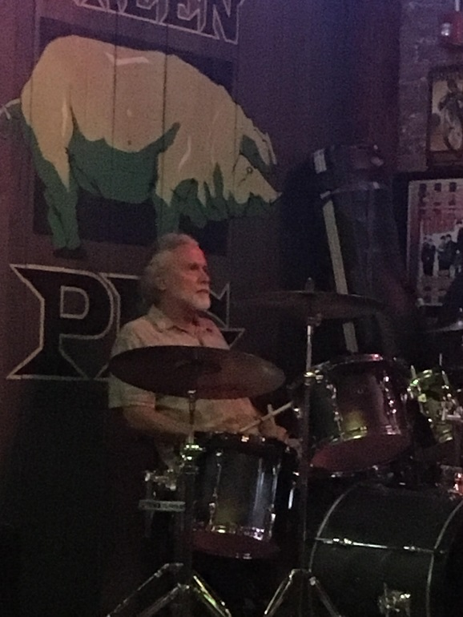
Let’s talk about the musicians now and learn about a few of them. We interviewed a couple of them on of them was there to play and the other was there to enjoy and if he needed to jump up on stage to keep the blues line going then he would gladly do that. The first person interviewed was Kevin “The love Muffin”. He first started playing out as at the age of 15 or 16. He is well versed in multiple instruments. He always favored percussion. The night of the jam session he was on drums and in this case, was one of the drummers that kept the band going. At one point one of the drummers that was on stage was struggling and Kevin was summoned to the stage by Gary to take his place so that the music would not stop flowing for one second. He has also throughout his life played the guitar. Which He noted was his next strongest instrument that he plays. Then he mentioned that as a kid he wanted to know how to play the flute so he borrowed his siblings flute and taught himself how to play. Lastly, he start that he dabbled in the piano and the saxophone a bit. He was asked how he was drawn to blues and he simply stated he first heard blues as a boy and loved how it spoke to him. From that point on he always drifted toward Blues. The next person we interviewed was Josh. He had come to our talk to talk and was gracious enough to allow us to interview him. Josh has been playing an instrument for as long as he remembered. He told us that he plays “the whole gammit”. He is partial to anything with strings and has gravitated towards that continually throughout his life. His next strongest instrument is percussion. We asked him when his first gig was and how that went. He replied to us by first laughing and said that his first time in front of a crowd in public was at the bayou. The Bayou is a southern bar an grill known for its traditional style food and music that goes along with it. So naturally Blues is a staple genre at that venue. He told us that the gig was rough and that he faltered a bit but that the other members of the band kept him on the right path throughout the set.
After observing all of the subcutures. We have seen how they can all come together to make up a good scene.

